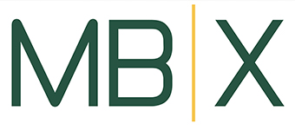

MBX SCO ANNUAL CREDIT CARD AGREEMENT FORM

The MBX credit card is available for Booster Clubs to use for purchases.
Please review the following conditions:

- The MBX credit card may ONLY be used for purchases over $1000.

- Mandatory Use: The MBX credit card MUST be used for any single purchase over $5000, or a purchase that totals over $5000 but is paid in installments.

- The MBX Credit Card Usage form MUST be completed prior to use and submitted to Leslie Whittet for approval (leslie@mbxfoundation.org). Once approved, send the final form and receipt(s) to Leslie.

- The form is located on the MBX website under the Booster Clubs/SCO tab.
The credit card information is available by contacting Leslie Whittet.

Booster Club: _____________________________

Authorized User(s) and email:

________________________________________________

________________________________________________

________________________________________________

I acknowledge and agree to the conditions above:

Signature:______________________________

Date: _________________________________

