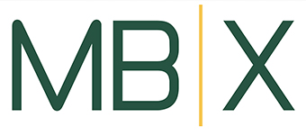

MBUSD/MBX EMPLOYEE DIRECT DEPOSIT SIGN-UP FORM

Please complete the following form and email to leslie@mbxfoundation.org

Why Direct Deposit?
It’s convenient and it saves time:
  - Your check is automatically deposited into your account.
  - It eliminates a trip to the bank.
  - It is safe and secure.

Date: _________________________________

Name:____________________________________________________
Address:__________________________________________________

City:_____________________________________________________
State: ____________________________________________________

Please have my payroll check automatically deposited into the following account:
□ Checking Acct. Number: __________________________________
Or
□ Savings / MIA / Money Market Account Number ________________________________________________________

Bank’s Routing Number: ____________________________________

