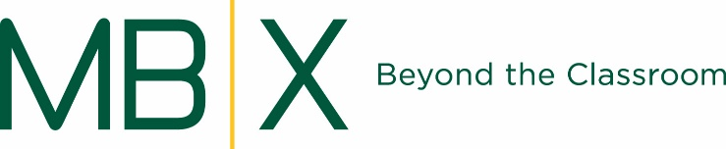

Summer School Opportunity!!
College Essay Writing Workshop
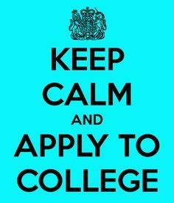
Coached by Shannon Vaughan, Mira Costa English Teacher
Are you a rising Senior? Are you starting to stress about college applications? Have you promised yourself you would get your essays finished over the summer? Then this class is for you.
Under the guidance of one of Mira Costa’s most loved and experienced teachers, this class will help you get organized and complete your personal statement and the common application essay. Ms. Vaughan has taught English at Mira Costa for over 30 years, helping her students craft and edit countless college applications. Bring your ideas and questions, and she’ll guide you through the application process with individual attention.
Class meets Mon/Tue/Wed. Choose one of 2 sessions:
June 21 – July 7: 8-11am
July 12 – July 28: 10am – 1pm
Tuition: $425 per session
Enrollment is limited. Click here to register.

