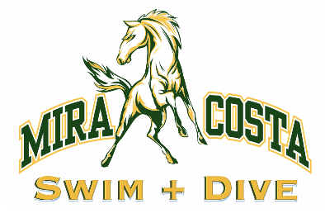
MIRA COSTA MUSTANGS STAMPEDE THE 2022 BAY LEAGUE CHAMPIONSHIPS
Undefeated throughout the season, Costa swim team wins Bay League in all divisions
MANHATTAN BEACH, Calif. – May 1, 2022 --The 2022 Bay League Swim Championships were held last week in Palos Verdes, and the Mira Costa swim team swept the competition. Six teams competed for the boys’ and girls’ titles with prelims held on Wednesday, April 27, and finals held on Friday, April 29. Teams that participated were Culver City High School, Mira Costa High School, Palos Verdes High School, Peninsula High School, Redondo Union High School, and Santa Monica High School.
“Given everything that has happened the last couple of years, this season was especially momentous for everyone involved,” said head coach Dave Halushka. “We entered Bay League with an enthusiasm and appreciation for being able to compete that really motivated our swimmers to perform at a higher level.”
Coach Ariana Silva noted, “I am so proud of the collective effort of our team. Costa swimmers had this intensity and commitment to bringing their best at every meet leading up to this moment and it was thrilling to see it all culminate at Bay League.”
The Mustangs won a remarkable 23 out of 42 events, breaking multiple Bay League records including the girls’ varsity 200 medley relay (swam by Mia Crisera, Iyanah Samayoa, Delaney Herr, and Shea Steggell) and 200 freestyle relay (swam by Maya Manasfi, Shea Steggell, Katie Kabealo, and Mia Crisera) and the boys varsity 200 Medley relay (swam by Zack Yakubik, Ben Tunila, Brad Diaz, and Denzel Tate) and 400 free relay (swam by Brad Diaz, Kyle Capili, Zack Yakubik, and Denzel Tate). Additionally, Costa Varsity Freshman Delaney Herr broke the Bay League record in the 100 fly. All these races also qualified for CIF.
“I also want to recognize the superb work of Coach Heidi Nelson, who oversaw race placement,” added Silva. “She had a strategy that went beyond putting the fastest kids in each race. Especially for relays, she knew how to leverage camaraderie and speed to create a competitive edge and ensure maximum scoring.”

Costa ended the meet with a total of 712 points in the men’s division and 671 points in the women’s division. Compared to Redondo Union High School, who came in 2nd in the women’s division (both JV and varsity) with 578 points, and 2nd place in men’s JV with 107 points. Santa Monica High School finished with 314 points to take 2nd place in the men’s varsity division.
The swimmers will now prepare for the CIF-Southern Section Division 1 meet on May 4 in Mission Viejo.
Contact: Monica Chun at monica.chun743@gmail.com with any questions. 310-402-1146

